**The Effects of ShotSpotter on Gun-Crime in Denver:**

**An Impact Evaluation**

**By**

**Marc L. Swatt, Ph.D.**

**Craig D. Uchida, Ph.D.**

**Allison Q. Land, M.S.**

**September 30, 2020**

This report was supported by Grant No. 2016-GP-BX-0011 awarded by the Bureau of Justice Assistance (BJA) to the Denver Police Department (DPD). BJA is a component of the U.S. Department of Justice, Office of Justice Programs. Points of view or opinions contained herein do not necessarily represent the official position or policies of the U.S. Department of Justice or the DPD.

We thank the Denver Police Department, the Denver ATF, and their law enforcement partners for their willingness to provide data and information regarding the Crime Gun Intelligence Center and ShotSpotter. Their cooperation was invaluable and without it we would not be able to complete this report.

**The Effects of ShotSpotter on Gun-Crime in Denver:**

**An Impact Evaluation**

**Background**

The Denver Police Department (DPD) and the Bureau of Alcohol, Tobacco, Firearms, and Explosives (ATF) formed the Crime Gun Intelligence Center (CGIC) in January 2013 (White & Franey, 2014). The goal of CGIC was to collect, process, and analyze forensic evidence from recovered firearms and bullet casings through the National Integrated Ballistics Information Network (NIBIN). This evidence can identify unknown perpetrators through linkages between firearms used in crimes both inside and outside the Denver area (see Kraft, 2018). Denver’s CGIC expanded to include a number of local agencies to increase the scope and reach of the NIBIN information (see Schaible & Six, 2017; White & Franey, 2014).

As part of efforts to increase the amount of firearm forensic evidence recovered, the city of Denver and the ATF installed the ShotSpotter acoustic firearm detection network. The ShotSpotter system relies on a series of fixed-location sensors designed to detect gunfire. These sensors are deployed within a specific area, typically a high gun crime location. When a gun is fired within this area, information from multiple sensors are then used to triangulate the location of the gunshot. By producing timely intelligence on the location of gunshots, ShotSpotter should enable police departments to respond faster in order to apprehend offenders and to receive more precise location information to increase the likelihood of obtaining ballistic forensic evidence.

ShotSpotter deployment occurred in a number of phases. The first phase, the North area, covers an area of three square miles north of the city park and came online January 8, 2015.1 An additional area in the southwest of the city, Districts 1, 4, Park Hill, and Sun Valley (referred to as the West area), consisting of 6.5 square miles began operation on April 23, 2016. Later that year on September 21, 2016, the Montbello area also came online, which covered approximately two square miles. After this, the East Colfax area consisting of 1.1 square miles began collecting information on March 30, 2018. The final area of Downtown Denver, which expanded the North Area by 1.5 square miles, began operating on July 9, 2020 (Unfortunately, the start date of this final area occurred after the end date of data collection for this project and is not examined in this evaluation). Figure 1 presents a timeline of the implementation dates of ShotSpotter.

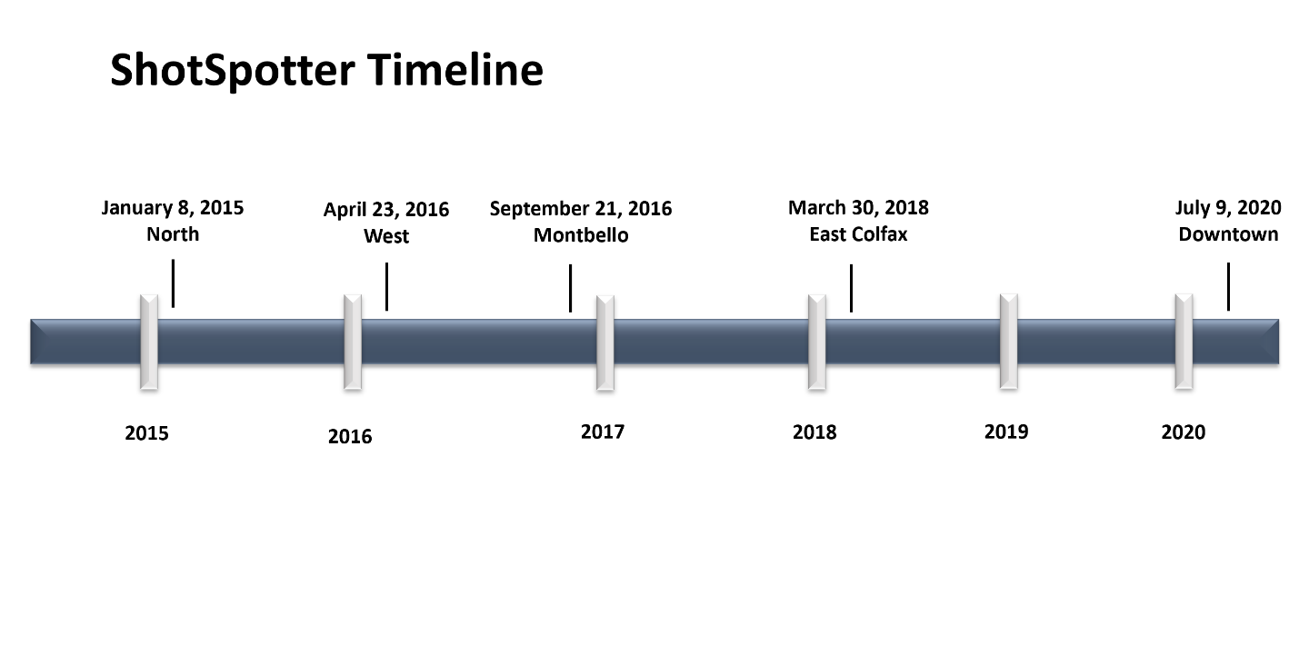

Figure 1. ShotSpotter Implementation Timeline

This report presents the results from an impact evaluation of the ShotSpotter implementation in Denver. Two additional reports – a process evaluation of CGIC/RAVEN and an impact evaluation of CGIC/RAVEN – accompany this report. In this evaluation, we focus only on the impact that ShotSpotter had on gun crime within Denver. Specifically, we examine whether the start dates of ShotSpotter correspond to changes in the amount of gun crime within each catchment area. First, we briefly review ShotSpotter and the empirical evidence of its effectiveness. Second, we describe the study’s methodology. This section starts with a brief description of the city of Denver to provide context for the study, after which we discuss the data, measures, the interrupted time series study design, and the statistical techniques used in the analysis. The results section follows which presents the study findings. In the final section, there is a brief summary of the results, a discussion of the limitations of the study, and a series of recommendations for future research and policy.

**Review of ShotSpotter**

ShotSpotter is an acoustic gunshot detection system designed to identify gun discharge events and the spatial location of the event within a designated catchment location. This system is reliant upon the installation of a set number of fixed acoustic sensors throughout the target area. The number and location of these sensors vary by the size and shape of the target area. When a gunshot occurs in the target area, the time differentials between the detections by multiple sensors are used to triangulate a location of the incident (Mares & Blackburn, 2012; ShotSpotter, 2020). These sensors can filter out background noises, such as wind and traffic, to detect an apparent gunfire event.

After the initial detection of the event, software is used to distinguish between the acoustic signature of gunfire from other types of loud events, such as car backfires, thunder, fireworks, and other loud sounds (ShotSpotter, 2020). ShotSpotter has recently integrated an automatic machine learning algorithm to verify that the detected acoustic signature is a likely gunfire incident. This information is then reviewed by personnel in the ShotSpotter Incident Review Center which validates the incident and forwards the information to dispatch and patrol officers. ShotSpotter suggests that the review process takes fewer than 60 seconds (see ShotSpotter, 2020).

Research confirms that acoustic detection systems are effective at detecting and triangulating crimes. Mazerolle and colleagues (1998; Mazerolle, Frank, Rogan, & Watkins, 2000; Watkins, Mazerolle, Rogan, & Frank, 2002) confirm that the ShotSpotter system was able to detect 80 percent of test fired shots and triangulated 84 percent of those shots within 25 feet.

Studies have found mixed results regarding police response times and acoustic detection systems. In their two-month field study, Mazerolle and colleagues (1998; Mazerolle et al., 2000) found that the SECURES acoustic detection system did not improve police response time. They also found there was a considerable increase in the number of police dispatches to gunshot incidents. In contrast, using a pre-test post-test design Choi, Librett, & Collins (2014) found that ShotSpotter reduced time to dispatch and response time for gunshot events. Goldenberg and colleagues (2019) found that ShotSpotter reduced both response time and travel time for both police and emergency medical services. Lawrence, La Vigne, & Thompson (2019) found that in Denver and Richmond, CA, call to arrival response time was faster for ShotSpotter detections than for citizen calls for service. However, in Milwaukee response time was slower than citizen calls for shootings where an individual was hit by gunfire but faster than citizen calls for shots fired generally.

***Previous Studies on Acoustic Gunshot Detection Systems and Crime***

While there are some encouraging results about the accuracy of acoustic detection systems and their potential to reduce police response time to gunfire incidents, few studies have been conducted to assess the impact of these systems on gun crime. The studies that have been conducted provide mixed to positive evidence in the effectiveness of acoustic detection systems.

Using an interrupted time series design in St. Louis, Mares and Blackburn (2012) found that an acoustic gunshot detection system was associated with a decrease in citizen reported gunshots. Unfortunately, it remained possible that citizens were less likely to call police in response to gunfire because they were aware of the technology operating in the neighborhood. They also did not find a consistent relationship between the presence of the acoustic detection system and gun crime.

Swatt, Crank, Irlbeck, and Sporer (2013) used an interrupted time series design to evaluate the ShotSpotter system implemented in a high crime area of Omaha, NE. They found that ShotSpotter led to a reduction of citizen-reported shots fired incidents compared to control areas. Since the citizens in the affected neighborhood in Omaha were not notified of the presence of ShotSpotter prior to the evaluation, it is possible to eliminate citizen awareness of the system as a reason for the decline. Unfortunately, the implementation of the system coincided with an abnormally high level of citizen reported shots fired calls for service, and intervention effects could be attributed to regression to the mean. Significant reductions were not observed for any other crime variables.

Ratcliffe, Lattanzio, Kikuchi, and Thomas (2018) used a partially block-randomized design to evaluate the impact of acoustic sensors paired with closed circuit television cameras. Comparing incidents within 900 feet for eight months before and after the intervention, they found that the number of gunshot incidents increased, but the number of confirmed shooting events was unaffected. This result suggested that these sensors resulted in an increase in police workload without a tangible benefit of discovering additional shooting events.

In the most thorough evaluation to date, Lawrence et al. (2019) conducted a series of panel regressions, interrupted time series analyses, and comparative time series analyses for the implementation of ShotSpotter in three cities: Denver (North Area only), Milwaukee (4 areas), and Richmond, CA (3 areas). In Denver, they found significant increases in calls for service for shooting-related incidents, crimes involving a firearm, and arrests for crimes involving a firearm in the panel model. In the interrupted time series model, they also found a significant increase in crimes involving a firearm immediately following implementation. In Milwaukee, they found significant decreases in calls for service for violent crimes (three sites) and significant increases in calls for service for shooting related crimes (all sites). They found an increase in violent crime and robbery in one site but a decrease in another site. In Richmond, they found significant increases in calls for service for violent crimes (one site), calls for service for shooting related crimes (all sites), but decreases in violent crimes and robberies (all sites). They also found significant decreases in crimes with firearms in two sites in Richmond.

***Current Study***

While there is some evidence that acoustic detection systems can reduce certain types of gun-related crime, this evidence is far from conclusive. Additional studies are needed to specifically evaluate the impact that these systems have on gun-involved crime. The implementation of ShotSpotter in the city of Denver provides an excellent opportunity to add to this research. Although the Lawrence et al. (2019) study relies on Denver as an evaluation site, their evaluation only examined the original intervention site (the North Area) for a short period after implementation. Since that time, the ShotSpotter system has expanded into three additional areas, with a fourth expansion that only recently became operational. The varying time of implementation for these sites provides a unique opportunity to assess the impact of ShotSpotter using an interrupted time series design with multiple controls. This methodology allows for comparisons of the impact of ShotSpotter as it was expanded at each site to assess whether there were consistent impacts on crime at each implementation. Further, comparisons to each site and to the rest of the city allows for control of extraneous factors that may coincide with each implementation date.

This evaluation examines the impact of ShotSpotter on the levels and trends of violent crime with a firearm, robbery with a firearm, and aggravated assault with a firearm in the North, West, Montbello, and East Colfax catchment areas. We compare these impacts to the areas of the city that are unaffected by ShotSpotter. First, we discuss the methodology used in this evaluation in more detail. Then we present the findings of the descriptive analysis, thematic maps, and time series models. Finally, we discuss the limitations of this study and the implication for future research and policy.

**METHODS**

***Site***

As of 2019, the city of Denver recorded a population of 727,211 residents. According to the U.S. Census Bureau (2019), the demographic breakdown of Denver’s population is predominantly White (80.9 percent), Black (9.8 percent), and Male (50.1 percent). An additional 45.1 percent identified as Hispanic or Latino. The reported median household income as of 2019 was $63,793 with a poverty rate of 11.7 percent. The Denver Police Department is one of the largest police agencies in the Rocky Mountain region, covering 154.9 square miles and is overseen by Chief Paul Pazen. DPD is comprised of six major police stations that are organized by Districts: District 1 Station (NW), District 2 Station (N Central), District 3 Station (SE), District 4 Station (SW), District 5 Station (NE), and District 6 Station (Downtown). Additionally, the Denver Police Department covers District 7, which consists of the Denver International Airport. Figure 2 provides a map of the DPD’s Police Districts and Precincts.

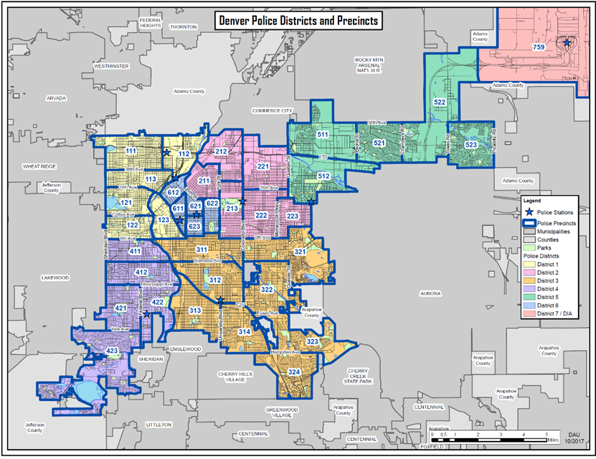

Source: Denvergov.org

Figure 2. Denver Police Department Districts and Precincts.

Table 1 below provides an overview of the crime rates per 100,000 residents for the city of Denver for the period of 2010 through 2019. These rates are calculated from the crime incident data provided by the Denver Police Department and the most recent estimated population data for the city of Denver (U.S. Census Bureau, 2019). In general, all crimes recorded by the DPD have increased yearly since 2010, but this trend appears to have stalled in recent years. The homicide rate appeared steady before dramatically increasing in 2015 and again in 2018. The rate of robberies experienced an increase in 2011 and 2012 but has remained stable through 2019. Finally, the rate of aggravated assaults increased through 2012 and then remained stable until 2015, where it began increasing again.



The four ShotSpotter areas examined in this report are presented in Figure 3. The first site that received the technology was the North Area outlined in pink. This area began operation on January 8, 2015. The West Area outlined in red was the second area that implemented ShotSpotter on April 23, 2016. The Montbello Area, outlined in purple, started operating on September 21, 2016. Finally, the East Colfax area outlined in yellow came online on March 30, 2018. The newest area of Downtown Denver is excluded from this report as it began on July 9, 2020, after the last date of data collection for these evaluations (June 30, 2020).

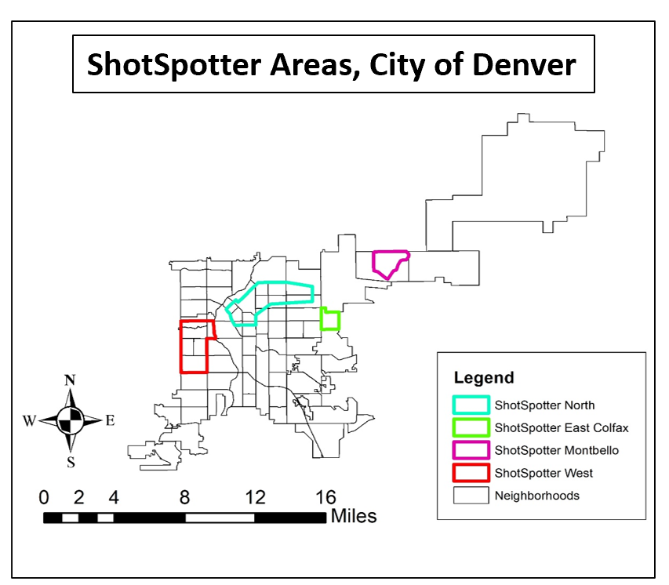

Figure 3. ShotSpotter Detection Areas.

In addition to the four ShotSpotter areas, we also required a control area that does not receive any ShotSpotter coverage. The main difficulty with identifying this area is that the ShotSpotter system can detect gunshots that occur outside the catchment area. Officers are deployed to these gunshot events, which implies that locations near the catchment location still receive benefit from the presence of ShotSpotter. Although this effect is beneficial to citizens, it creates problems during evaluation. Our solution to this problem was to examine the distribution of ShotSpotter initiated calls for service around each of the four target areas. We found that the most distant ShotSpotter call for service was over 3,500 feet from the boundary of the originating site. We then created a 3,600-foot buffer zone around each of the catchment areas. Figure 4 shows the locations of the buffer zones around each target location. The area outside all the buffer zones serves as a non-equivalent control for all the areas. Although the extent and distribution of crime is not similar to the catchment areas, this area still serves as an acceptable control area because we are only interested in whether there are observed changes in crime corresponding to the start time of each ShotSpotter site. Since this area should not be affected by ShotSpotter, finding that crime changes when ShotSpotter began in one of the target areas is evidence against the success of ShotSpotter.

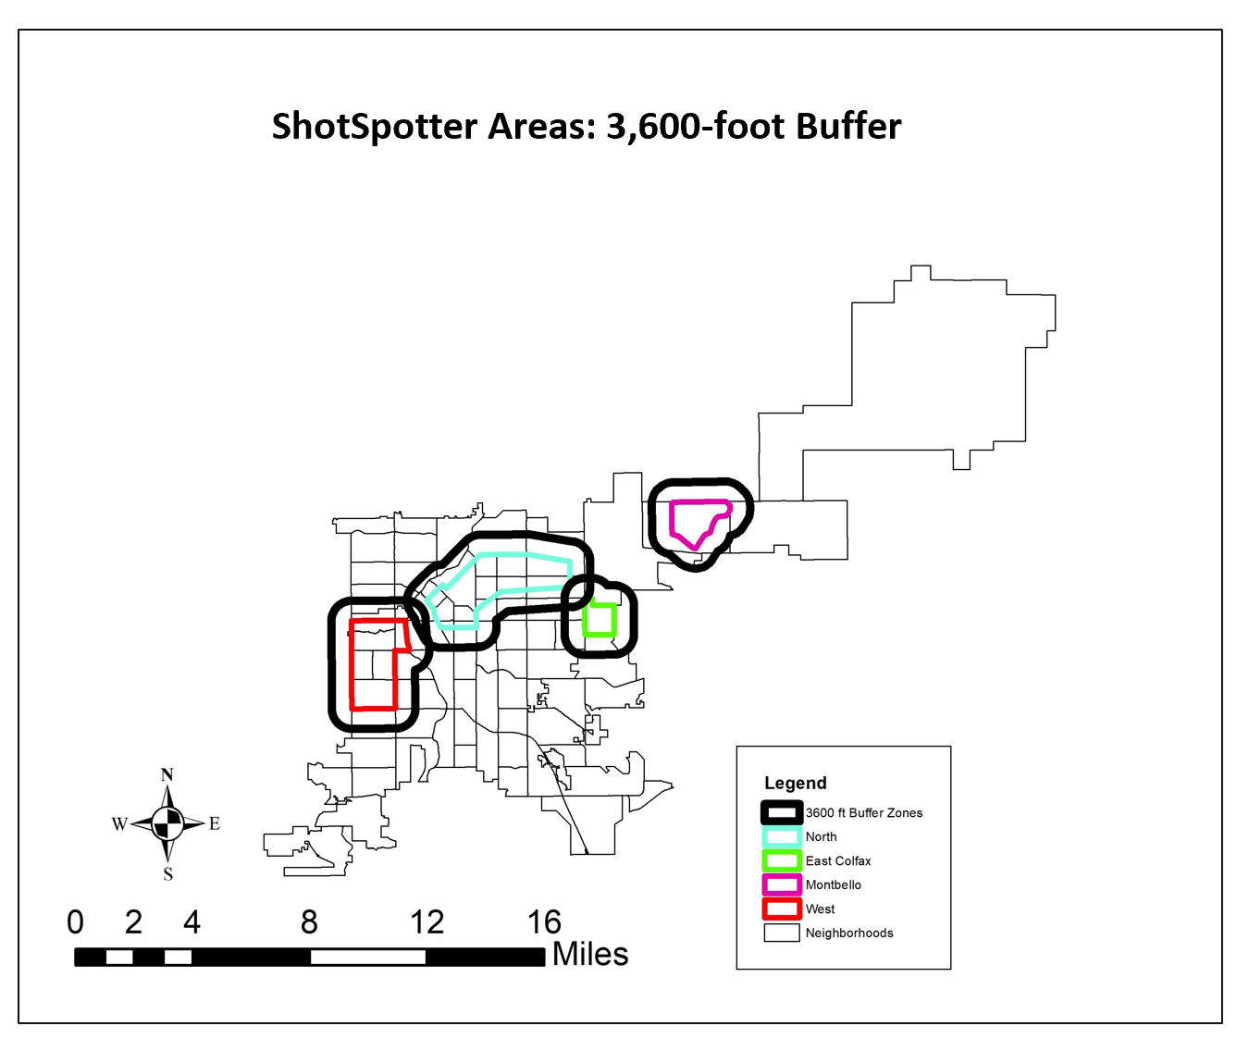

Figure 4. Location of Buffer Zones around the ShotSpotter Detection Areas.

***Data***

For this evaluation, the Denver Police Department provided data on all crime incidents spanning January 1, 2010 to June 30, 2020 (Q2 2020). Only data through 2019 is considered in this evaluation.2 The DPD recorded 577,119 incidents during this period.3 The incident data were used to obtain monthly crime counts for each of the ShotSpotter areas as well as the area Outside the Buffer Zones.

The DPD also provided calls for service data for this same period. In this system, calls originating from ShotSpotter were identified using a unique source indicator and can be separated from citizen-initiated and officer-initiated calls for service. These data are used for descriptive purposes.4

We consider three main outcomes in this study: robbery with firearms, aggravated assaults with firearms, and serious violent crimes with firearms. A criminal event is considered to involve a firearm if the DPD recorded the presence or use of any handgun, rifle, or other non-homemade firearm. Serious violent crimes with firearms is an aggregate measure of homicides, sexual assaults, robberies, and aggravated assaults involving a firearm. While reliance on official police reports may understate the extent of crime experienced by residents, underreporting of criminal events is much lower for serious crime (see Mosher et al., 2011; O’Brien, 1985).

***Research Design***

Because the ShotSpotter interventions have fixed start dates, an Interrupted Time Series (ITS) design was used to evaluate their effectiveness. The ITS design is a strong quasi-experimental design that allows for control over many of the threats to internal validity that can compromise conclusions about the effectiveness of interventions (see Campbell & Stanley, 1963; Cook & Campbell, 1979; Shadish, Cook, & Campbell, 2002). One of the key features to a time series design is that there is a sequence of observations taken before and after the intervention occurs. For this evaluation, there is an added benefit that each intervention site began operating at different times. This considerably strengthens the research design as the sites can operate as controls for each other. Figure 5 below illustrates how this strategy works.



Figure 5. Diagram of the Interrupted Time Series Design with Comparison Groups.

The pretest consists of a series of observations on each of the four test locations and the area outside the buffer zone. This pretest provides for a method to estimate the pre-existing trends in crime prior to any intervention. The first intervention occurs only in the North Area, followed by a period of observations for the posttest of this intervention. If ShotSpotter is effective, there should be a decrease beginning with the start time of the intervention, observed only for the North Area and no other area. After this, a second intervention occurs in the West Area followed by a series of posttest observations. Again, there should only be a decrease in crime associated with the West Area and no other area, including the North Area. After this, the Montbello Area receives the intervention, and crime reduction should be observed in the posttest only for this area. Finally, the East Colfax area receives the intervention with the posttest confirming whether a drop in crime was seen only in this area. The area Outside the Buffer Zones serves as a control for all areas and should not experience decreases in crime corresponding to the start dates of the other interventions.

The strength of this design is that it protects against “history” effects, where an event influences crime simultaneously to the time when the intervention occurs. The influence of history is observed if areas other than the intervention site experiences a simultaneous decrease in the same type of crime. Detecting this pattern indicates that an outside event may be associated with the observed decreases in crime.

***Plan of Analysis***

Descriptive analyses provide baseline information about the extent of gun crime in the target areas before and after the intervention. Hotspot maps provide information about the distribution of gun crime within the target areas. Additionally, grid cell thematic maps are used to highlight changes within these target areas one year before and one year after the intervention occurs. Local polynomial graphs for the three outcome variables (serious violent crime with a firearm, robbery with a firearm, and aggravated assault with a firearm) are examined to better understand the trend in these crimes over time. These graphs provide an opportunity to check for non-linearities in the crime trends. Additional information on the local polynomial graphs can be found in the Technical Appendix (see page 40).

Ordinary Least Squares (OLS) and negative binomial segmented regression analysis with Newey-West adjusted standard errors estimate the impact of ShotSpotter on the three gun crime measures for each target area. Data prior to 2014 is excluded from these analyses as these data may reflect the impact of CGIC implementation that occurred January 2013 (see the accompanying evaluation of CGIC). The segmented regression approach controls for the pre-existing level and trend of crime before the intervention. The intervention effect is estimated by the coefficients for the intervention and the intervention × time interaction. The coefficient for the intervention can be interpreted as the *immediate drop in the level of crime* when the intervention started. The coefficient for the intervention × time interaction can be interpreted as *the change in the trend of crime* after the intervention. For the negative binomial models, the coefficients cannot be interpreted directly. Following the recommendation of Long and Freese (2014), (*exp*(*b*) – 1) can be interpreted as the percentage change in the count of events for a one unit increase in the independent variable. Additional information on the segmented regression approach can be found in the Technical Appendix.

**RESULTS**

***Descriptive Analysis***

When a gunshot or a sound that emulates a gunshot occurs in a catchment area the ShotSpotter system is activated. The sound is then reviewed at the ShotSpotter Incident Review Center, and the information is then sent to Denver’s 911 communications center. The information is recorded as a ShotSpotter alert. After the alerts arrive at the 911 call center, these alerts are then converted to calls for service with a designation of “ShotSpotter” as the source of the call. Importantly, this conversion process is not 1:1 as some alerts for repeat events are combined into a single call for service, while other alerts do not generate a call for service at all. Across the 5-year sample period, ShotSpotter recorded 6,858 calls for service across all four locations.

Table 2 displays the distribution of ShotSpotter-initiated calls for service from 2015-2019. The years prior to 2019 provide an idea of how the distribution of ShotSpotter calls have changed over time, but the trends are not directly interpretable. In 2019, all ShotSpotter Areas had been operating across the entire year and the relative distribution of calls can be seen. In 2019, the West area had the most ShotSpotter originated calls for service, accounting for 42.8 percent of all ShotSpotter calls. After this, the North Area was responsible for 35.2 percent of all ShotSpotter calls. The Montbello Area only produced 17.4 percent of all ShotSpotter calls. Finally, East Colfax produced the least ShotSpotter calls and was responsible for only 4.5 percent of the total.



*Gun Crime in ShotSpotter Areas.*

As a preliminary assessment of the impact of ShotSpotter on violent and firearm-related violent crime, descriptive analyses of changes in crime provide a useful starting point. Table 3 displays violent crime rates per 100,000 residents based on the newest Census population estimates (U.S. Census Bureau, 2019). Five-year averages were used for the pre- (2010-2014) and post- (2015-2019) ShotSpotter periods. For all crime types, the post-ShotSpotter periods recorded higher violent crime rates. The homicide rate increased 55.7 percent, the aggravated assault rate increased 27.3 percent, and the robbery rate increased by 4.6 percent.

Table 3. Violent Crime Rates Pre-and Post-ShotSpotter Implementation.

|  |  |  |  |
| --- | --- | --- | --- |
|  | **5-year Average: 2010-2014** | **5-year Average: 2015-2019** | **% Change** |
| Aggravated Assault | 333.36 | 424.39 | +27.3% |
| Homicide | 5.28 | 8.22 | +55.7% |
| Robbery | 159.79 | 167.16 | +4.6% |

Table 4 displays the trends in firearm-related violent crime rates pre and post ShotSpotter implementation. There are greater increases in the rates of firearm-related violent crime, with firearm homicides displaying the most prominent increase (94.4 percent).

Table 4. Firearm-RelatedViolent Crime Rates Pre and Post-ShotSpotter Implementation.

|  |  |  |  |
| --- | --- | --- | --- |
|  | **5-year Average: 2010-2014** | **5-year Average: 2015-2019** | **% Change** |
| Firearm Agg. Assault | 95.90 | 143.42 | +49.6% |
| Firearm Homicide | 3.03 | 5.89 | +94.4% |
| Firearm Robbery | 56.76 | 62.79 | +10.6% |

Finally, Table 5 presents the percentage of homicides, robberies, and aggravated assaults committed with a firearm in the pre and post ShotSpotter periods. The percentage of violent crime committed with a firearm increased for homicides, robberies, and aggravated assaults. Again, homicides show the greatest increase at 14.3 percent.

Table 5. Percentage of Violent Crime Committed with a Firearm, Pre and Post ShotSpotter.

|  |  |  |  |
| --- | --- | --- | --- |
|  | **5-year Average: 2010-2014** | **5-year Average: 2015-2019** | **% Change** |
| % of Homicides with a firearm | 57.3% | 71.6% | +14.3% |
| % of Robberies with a firearm | 35.5% | 36.8% | +1.3% |
| % of Agg. Assaults with a firearm | 28.8% | 33.8% | +5.0% |

***Violent and Firearm-Related Violent Crime Hot Spots***

Kernel density hot spot maps provide a method to assess how violent and firearm-related violent crime changed over time. Kernel density estimation is a method of spatial smoothing that uses a kernel function to generate a spatial density based on the locations of crime incidents (see Levine, 2013). The hot spot maps that are generated using this procedure provide a visual representation of the density of crime in specific locations and allow us to visualize where crime is ‘hottest’ at certain points in time. The following maps in Figure 6 display firearm-related violent crime (aggravated assaults, robberies, and homicides) for the same five-year pre-and post-ShotSpotter implementation periods. From the maps, it appears that the hot spots did not change from the pre-to-post ShotSpotter periods. The ‘hottest’ areas, or the areas with the highest firearm-related violent crime densities, are located within the ShotSpotter catchment areas, which indicates that these were the correct areas to place ShotSpotter.

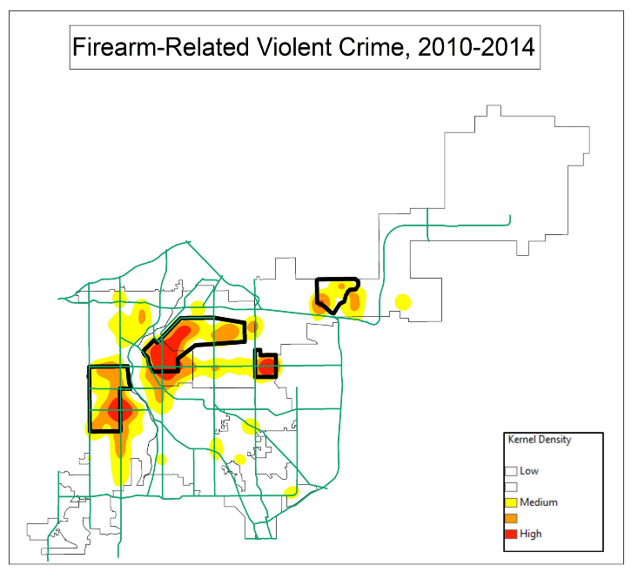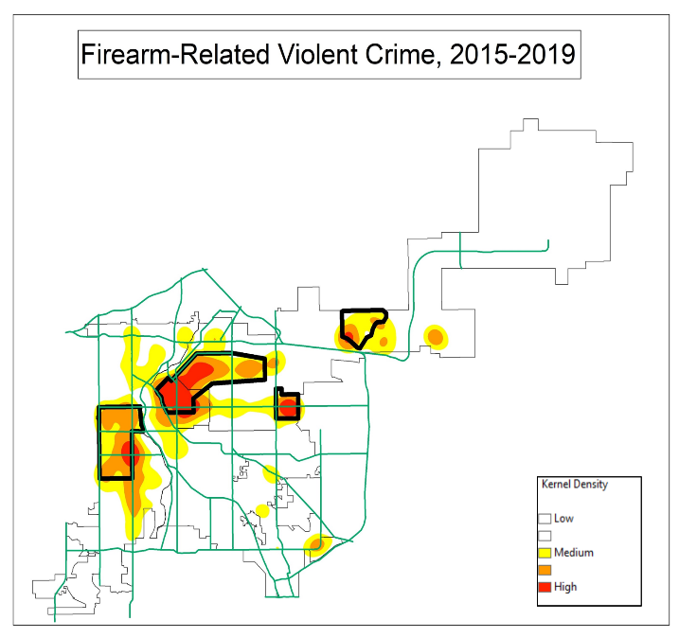

Figure 6. Pre- and Post-ShotSpotter Locations for Violent Crime with a Firearm, 2010-2019

***ShotSpotter Area Thematic Maps***

In order to visualize how the ShotSpotter affected crime within the ShotSpotter catchment areas, thematic maps for each of the ShotSpotter locations were constructed. Each map contains 1,000-foot by 1,000-foot grid cells, and the colors represent the number of crime incidents that occurred in each grid. For this analysis, we define the pre-implementation period as the year prior to the date each ShotSpotter system came online, and we define the post-implementation period as the year following the date of implementation. Table 6 provides the start and end dates for the pre- and post-intervention time periods as well as the number of grid cells in each area. The North ShotSpotter location contained 215 1,000 ft. x 1,000 ft. grid cells, ShotSpotter West was comprised of 143 grid cells, ShotSpotter Montbello contained 75 grid cells, and ShotSpotter East Colfax contained 38 grids cells.

Table 6. ShotSpotter Pre-and Post-Implementation Dates by Area

|  |  |  |  |
| --- | --- | --- | --- |
| **ShotSpotter Area** | **Pre-Implementation Period** | **Post-Implementation Period** | **Number of Grid Cells** |
| North | 1/8/2015 - 1/7/2016 | 1/8/2016 - 1/7/2017 | 215 |
| West | 4/23/2015 - 4/22/2016 | 4/23/2016 - 4/22/2017 | 143 |
| Montbello | 9/21/2015 - 9/20/2016 | 9/21/2016 - 9/20/2017 | 75 |
| East Colfax | 3/30/2017 - 3/29/18 | 3/30/2018 - 3/29/19 | 38 |

*ShotSpotter North*. Figure 7 provides a visual representation of firearm-related violent crime in the North ShotSpotter location. From the maps, it appears that firearm-related violent crime increased in multiple grid cells. The blue cells represent zero violent crimes, and there are 29 fewer blue grid cells in the year following the implementation of ShotSpotter North. Table 7 confirms what the map displays: in the post-ShotSpotter period, violent crime increased for all respective categories with the exception of the “0” category. Spatially, violent crime is less concentrated, but this could be a function of the increase in the number of crimes in this area.

Table 7. Count of Violent Crime with a Firearm in North Area, Pre-and-Post ShotSpotter Implementation

|  |  |  |  |  |  |
| --- | --- | --- | --- | --- | --- |
|  | **Cells with 0 Crimes** | **Cells with 1 to 2 Crimes** | **Cells with 3 to 6 Crimes** | **Cells with 7 to 12 Crimes** | **Cells with 13+ Crimes** |
| Gun Violent Crime - Pre | 141 | 51 | 17 | 5 | 1 |
| Gun Violent Crime - Post | 112 | 59 | 29 | 12 | 3 |

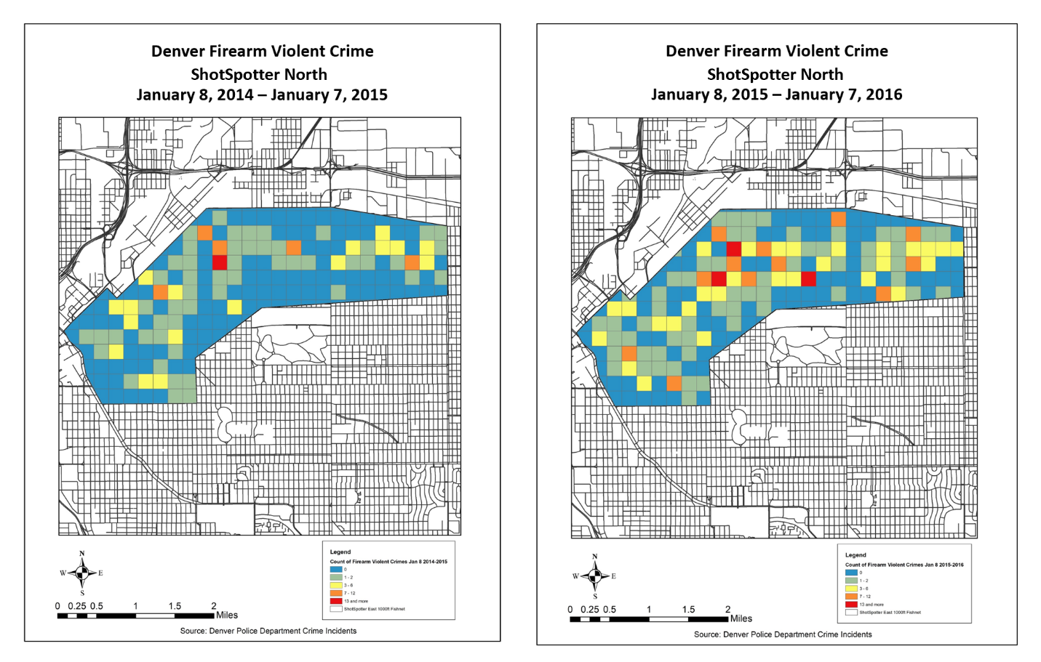

Figure 7. Violent Crime with a Firearm in North Area, Pre-and Post-Implementation

*ShotSpotter West*. Table 8 and Figure 8 display changes to violent firearm-related crime in the West ShotSpotter area. Visually it appears that firearm-related violent crime decreased in the post-implementation period. In the year following Shot Spotter’s implementation in this area, there were 18 more cells with zero firearm-related violent crimes. However, two more grid cells contained six or more violent crimes.

Table 8. Count of Violent Crimes with a Firearm in West Area, Pre-and-Post Implementation

|  |  |  |  |  |  |
| --- | --- | --- | --- | --- | --- |
|  | **Cells with 0 Crimes** | **Cells with 1 Crime** | **Cells with 2 to 3 Crimes** | **Cells with 4 to 5 Crimes** | **Cells with 6+ Crimes** |
| Gun Violent Crime - Pre | 63 | 34 | 31 | 11 | 4 |
| Gun Violent Crime - Post | 81 | 26 | 19 | 11 | 6 |

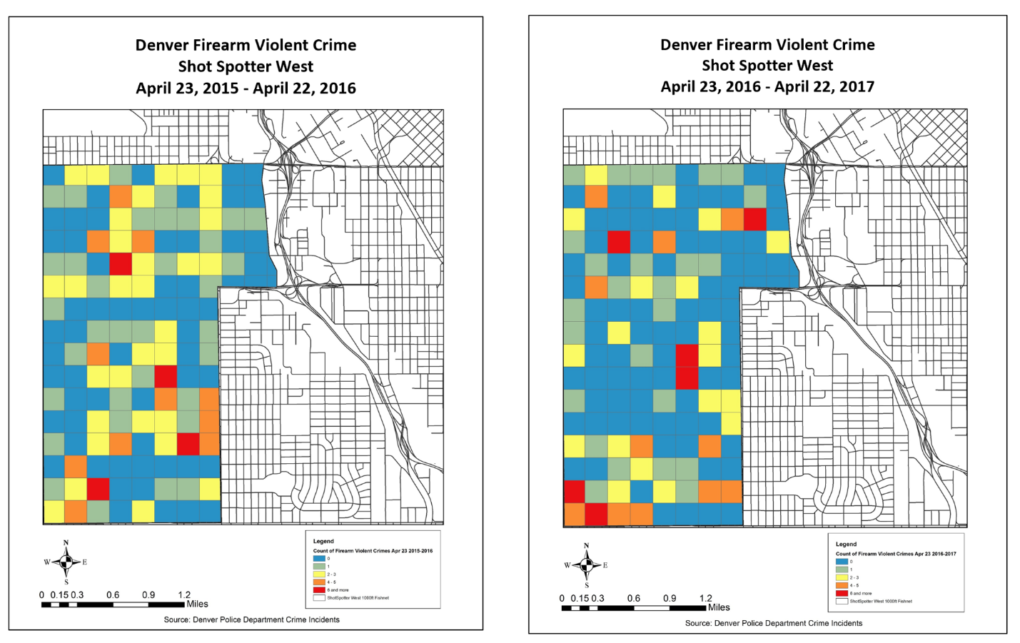

Figure 8. Violent Crime with a Firearm in West Area, Pre-and Post-Implementation

*ShotSpotter Montbello*. The firearm-related violent crime counts for the Montbello Area are presented in Table 9 and Figure 9. There are considerably fewer grid cells in the Montbello Area due to its smaller size compared to the North and West Areas. In the year following implementation, Montbello recorded two fewer cells with eight or more violent crimes, one fewer cell with six to seven violent crimes, and two more cells with zero violent crimes.

Table 9. Count of Violent Crime with a Firearm in Montbello Area, Pre-and-Post Implementation.

|  |  |  |  |  |  |
| --- | --- | --- | --- | --- | --- |
|  | **Cells with 0 Crimes** | **Cells with 1 to 2 Crimes** | **Cells with 3 to 5 Crimes** | **Cells with 6 to 7 Crimes** | **Cells with 8+ Crimes** |
| Gun Violent Crime - Pre | 42 | 23 | 6 | 1 | 3 |
| Gun Violent Crime - Post | 44 | 23 | 7 | 0 | 1 |

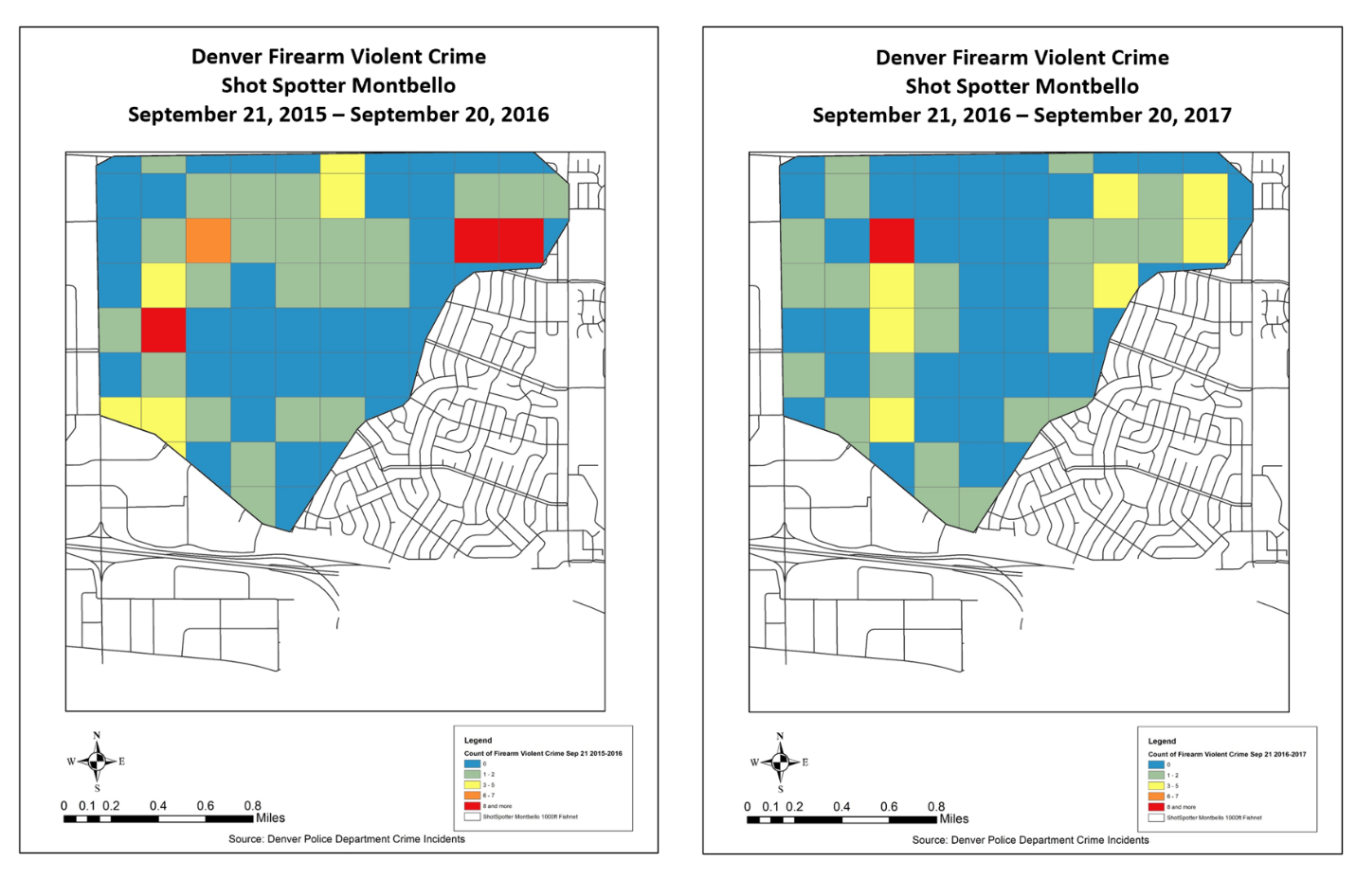

Figure 9. Violent Crime with a Firearm in Montbello Area, Pre-and Post-Implementation

*ShotSpotter East Colfax*. Table 10 and Figure 10 display firearm-related violent crime in the East Colfax ShotSpotter area. In the post-implementation period, East Colfax recorded one fewer grid cell with nine or more firearm-related violent crimes, two fewer cells with one to two firearm-related violent crimes, and three more grid cells with no firearm-related violent crimes relative to the pre-implementation period.

Table 10. Count of Violent Crime with a Firearm in East Colfax Area, Pre-and Post-Implementation.

|  |  |  |  |  |  |
| --- | --- | --- | --- | --- | --- |
|  | **Cells with 0 Crimes** | **Cells with 1 to 2 Crimes** | **Cells with 3 to 4 Crimes** | **Cells with 5 to 8 Crimes** | **Cells with 9+ Crimes** |
| Gun Violent Crime - Pre | 20 | 9 | 5 | 3 | 1 |
| Gun Violent Crime - Post | 23 | 7 | 5 | 3 | 0 |

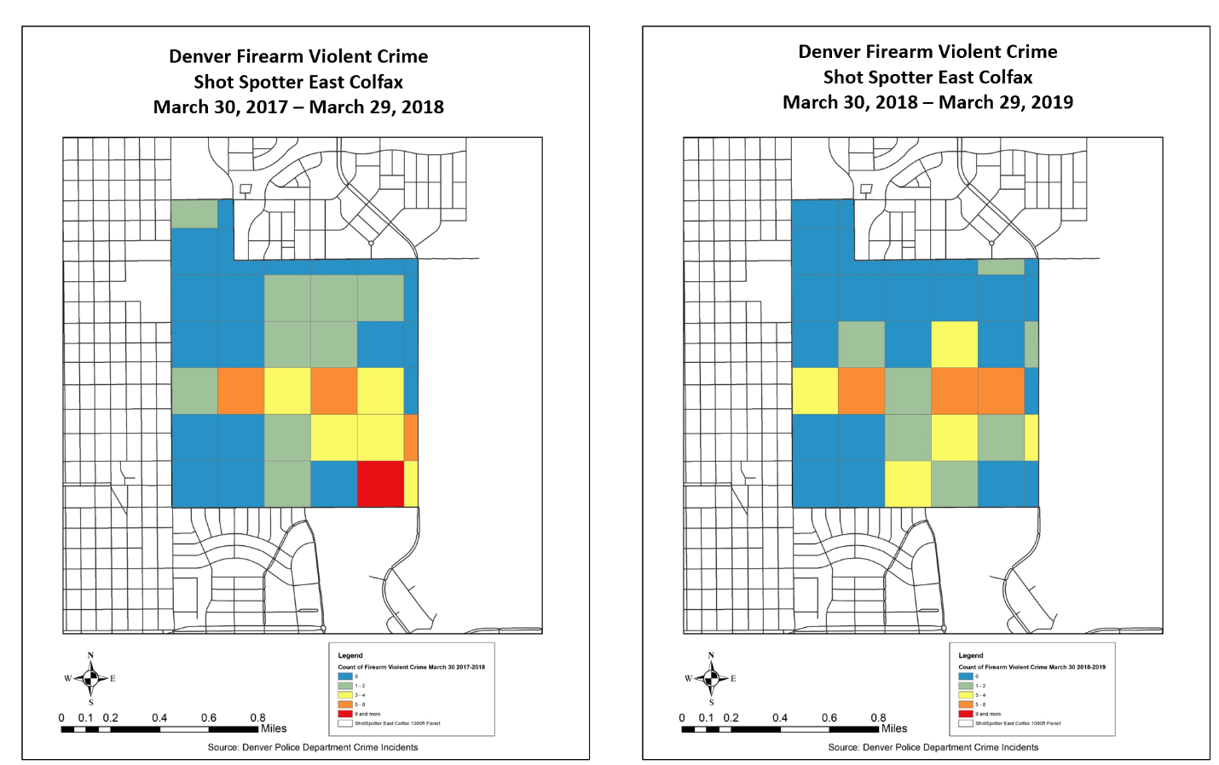

Figure 10. Violent Crime with a Firearm in East Colfax Area, Pre-and Post-Implementation

***Time Series Analysis***

Descriptive statistics for the monthly crimes counts for each area are provided in Table 11. The North Area location experiences the most gun-related crime on a monthly basis with an average of approximately 23 violent crimes with a firearm per month, 17 aggravated assaults with a firearm per month, and nearly 5 robberies with a firearm per month. After this, the West Area experienced the second highest averages of firearm crime with an average of 14 violent crimes, 9 aggravated assaults, and 4 robberies per month. The Montbello Area experienced fewer crimes still with a monthly average of eight violent crimes, seven aggravated assaults, and one robbery with firearms. The East Colfax Area had the lowest counts of gun-related crime with an average of four violent crimes, two aggravated assaults, and one robbery with firearms. Even though these ShotSpotter areas include some of the hottest hotspots for gun crime in the city, there was still an average of 49 violent crimes, 31 aggravated assaults, and 17 robberies with firearms per month in the remainder of the city outside of the buffer zones around the ShotSpotter areas.

In order to determine whether ShotSpotter had an impact on violent gun crime in each target area, we first examined local polynomial regression models as a descriptive method for assessing crime trends as well as a diagnostic method for subsequent analyses. After this, we conducted a series of Ordinary Least Squares (OLS) and negative binomial Newey-West segmented regression models. The results of these models are presented in the Technical Appendix. Interested readers should examine this section for additional details on the models. Instead, we summarize the results of these models by area in the section below.



*North Area.*

Table 12 presents the results of the final segmented regression models for the North Area. In our models, ShotSpotter had a statistically significant impact on both violent crime with a firearm and aggravated assault with a firearm. For violent crime with a firearm, crime was 7.3 percent lower per month compared to the pre-intervention trend. For aggravated assault with a firearm, crime was 10.9 percent lower per month compared to the pre-intervention trend. Unfortunately, similar statistically significant effects were observed in the area Outside the Buffer Zone for aggravated assault and in the West area for violent crime and aggravated assault. In sum these results present mixed evidence for ShotSpotter as significant reductions were observed but the contribution of other factors besides ShotSpotter cannot be ruled out.



*West Area*.

The results of the final models for the West Area are presented in Table 13. ShotSpotter had a statistically significant effect on violent crime with a firearm, robbery with a firearm, and aggravated assault with a firearm. For violent crime with a firearm, we observed an immediate decrease of 54.6 percent of crime the month ShotSpotter became active and a 5.5% decrease in crime compared to the pre-intervention trend. For robbery with a firearm, we observed an immediate decrease of 75.5% of crime the month that ShotSpotter came online. Finally, for aggravated assault with a firearm, we observed an immediate decrease of 48.8% of crimes the month that ShotSpotter began and then a decrease of 7.3 percent per month compared to the pre-existing trend. As with the North Area, significant effects are observed at other sites as well. Specifically, the East Colfax Area experienced a significant increase in violent crime with a firearm and an increase in aggravated assault with a firearm starting when the West Area became active. This does not appear to be evidence of a history effect and the results in the West Area are the strongest evidence in favor of an effect for ShotSpotter. This increase could be interpreted as a crime displacement effect; however, given the geographic distance between the West Area and East Colfax Area, this appears unlikely.



*Montbello Area*.

The summary results from the Montbello Area are displayed in Table 14. In this area, we found there was an immediate decrease of 47.4 percent of violent crimes with a firearm when ShotSpotter began operating. However, this finding is offset by the significant reductions in violent crime with a firearm and aggravated assault with a firearm that occurred at the same time in the East Colfax Area. These results offer very weak evidence for ShotSpotter as the impact in Montbello is limited to a weak effect on the aggregate measure of violent gun crime and stronger effects were observed in another area besides the target area.



*East Colfax Area*.

Table 15 presents the summary results for the East Colfax area. As this table highlights, there were no observed significant effects for ShotSpotter in East Colfax. There is no evidence suggesting ShotSpotter was effective in East Colfax.



*Summary*.

As a whole, the results of these analyses suggest that there is mixed evidence regarding the impact of ShotSpotter on violent gun crime. The results from the West Area are very encouraging as we see significant results that cannot be attributed to outside factors. However, the results from the North Area and Montbello Area suggest that ShotSpotter may be effective, but other factors may be operating across the city. Finally, we find no evidence in favor of ShotSpotter in East Colfax. The lack of consistency in the results across target areas also suggests that the impact of ShotSpotter is unclear.

**SUMMARY AND CONCLUSIONS**

***Summary***

This study provided an impact evaluation for the ShotSpotter system in use by the city of Denver. In collaboration with the Bureau of Alcohol, Tobacco, Firearms, and Explosives, the City of Denver and the Denver Police Department installed the ShotSpotter acoustic gunshot detection system. Acoustic gunshot detection systems rely on a series of sensors that detect the audio signal of a potential gunfire event. Using information from the waveform of the signal as well as the time it takes to be detected by other sensors, ShotSpotter can determine whether an acoustic signal was a gunshot and triangulate the location to the shooter. It is assumed that quicker information flow and more accurate location information will enable faster response time, more evidence collected, more victims saved, and more shooting suspects arrested.

The implementation of ShotSpotter proceeded in a number of phases. The first phase, the North area began operating on January 8, 2015. An expansion of ShotSpotter coverage in the West Area became operational on April 23, 2016. Later that year on September 21, 2016, the Montbello area also came online. After this, the East Colfax area began operations on March 30, 2018. The final area of Downtown Denver, which expanded the North Area, began operating on July 9, 2020, and sufficient information was not available at the conclusion of the data collection phase of this project. The phased implementation approach allowed for the use of an Interrupted Time Series design with Multiple Controls, a particularly strong quasi-experimental design.

Descriptive analysis was used to examine the workflow associated with ShotSpotter calls for service as well as providing the context of criminal activity within the target areas. Thematic maps of 1,000 foot by 1,000 foot grid cells provided preliminary evidence for a reduction in some types of violent crime in particular target areas. Local polynomial graphs were used to examine the trends in violent crimes with firearms, robberies with firearms, and aggravated assaults with firearms. Finally, a series of OLS Newey-West segmented regression models and negative binomial Newey-West segmented regression models were used to assess the impact of ShotSpotter across the four target areas, as well as the area of Denver lying outside of the 3,600 ft. buffer zones around each target location.

The results of this study are mixed. First, we found that ShotSpotter resulted in a statistically significant decrease in violent crimes with a firearm and aggravated assault with a firearm. However, significant effects corresponding to the start date of this intervention were also observed for aggravated assault with a firearm in the area outside the buffer zones and for violent crime with a firearm and aggravated assault with a firearm in the West Area. This suggests that while ShotSpotter appears to have an impact on violent crimes and aggravated assaults in the North Area, it is possible that these effects are due to an outside factor that also decreased these crimes in other areas of Denver.

Likewise, we observed statistically significant decreases in violent crime with a firearm, robbery with a firearm, and aggravated assault with a firearm in the West Area corresponding to the start of ShotSpotter. However, we also observed statistically significant effects for violent crime and robbery in the East Colfax area. Importantly, these effects were positive suggesting an increase in violent crime and robbery. While this does not necessarily compromise the results in the West Area, they do raise the possibility of displacement. We are hesitant to accept this explanation, as there is considerable geographic distance between the West and East Colfax Areas. It is our view that the results in the West Area represent the strongest evidence in favor of an effect for ShotSpotter.

We also detected a statistically significant effect of ShotSpotter on violent crime with a firearm in the Montbello Area. However, the East Colfax area also experienced a decrease in violent crime and robberies corresponding to the start time of ShotSpotter, again suggesting an outside event may explain the observed decreases in crime in Montbello. Finally, there was no evidence for an impact of ShotSpotter on any crime type in the East Colfax Area.

***Limitations***

There are a number of limitations in the current research that need to be considered when drawing conclusions from these findings. First, while the Interrupted Time Series Design with Multiple Controls is a methodologically strong quasi-experimental design, it does not offer as strong protections against threats to internal validity as a randomized experiment. The randomized experimental design remains the “gold standard” in evaluation research as it offers protection against the classic threats to validity. While the single site ITS design is vulnerable to the threat of history, the multiple ITS is not vulnerable to this threat. As previously mentioned, history effects are detectable as when apparent treatment effects are observed in control sites. However, this design is vulnerable to history x selection interaction effects. Specifically, conclusions might be compromised if there are unique events that occur in only one site corresponding to the timing of the intervention. Since the areas where ShotSpotter are implemented are also historical hot spots for criminal activity, it is possible that initiatives by the DPD or other agencies to reduce crime may have been occurring in one or more of these neighborhoods at the same time that ShotSpotter was implemented.

Another important limitation to this study is that these results may not be generalizable to locations outside of Denver. Since Denver was the only ShotSpotter site investigated, the results of the evaluation may be contingent upon unique sociodemographic characteristics of the city or its hot spot areas. Further, these results may also be contingent upon how Denver implemented ShotSpotter or integrated ShotSpotter information into its daily operation. Other cities may have very different experiences with the ShotSpotter system.

Finally, we only considered the impact of ShotSpotter on a very narrow range of criminal activity. While it is sensible that ShotSpotter should have an impact on violent gun crime, ShotSpotter may have impacts on other types of gun crime, such as illegal weapons carrying, illegal discharge of a firearm, or destruction of property with a firearm. Further, ShotSpotter may have an indirect effect on other types of crime as the increased police presence due to additional deployments to the target area may produce a deterrent effect on other crime types.

***Recommendations for Future Research***

The first recommendation from this evaluation for future research is simply that additional research on acoustic gunshot detection systems is needed. While the results of this evaluation are mixed, there still is evidence that the ShotSpotter system had an impact on gun crime in the West Area. This suggests that more studies are needed to determine whether acoustic gunshot detection systems can have an impact on crime. While true experimental designs may not be feasible given the cost of the system, future research would benefit from strong quasi-experimental evaluations. Future research would also benefit in examining additional outcomes beyond measures of crime. For example, the study by Goldenberg and colleagues (2019) found that ShotSpotter can reduce pre-hospital time for gunshot victims. Examining other outcomes such as these may demonstrate a beneficial impact beyond reducing crime.

A second recommendation is for future research to examine whether the relationship between acoustic gunshot detection systems and crime reduction is moderated by the social and demographic characteristics of the areas in which they are installed. In this study, ShotSpotter only had a significant impact in the two highest crime locations. The impact of ShotSpotter in an area might depend on exceeding a particular threshold in gun crime. Further, it is possible that ShotSpotter can have an impact in areas where people are generally disinclined to call the police in response to shooting events. In essence, ShotSpotter might help fill the gap of providing actionable intelligence to police officers in neighborhoods where residents are unlikely to provide information about individuals involved in gun crime.

A final recommendation for future research is to investigate further the benefit in pairing an acoustic gunshot detection system with closed circuit television (CCTV) cameras. While Ratcliffe and colleagues (2018) examined the impact of pairing acoustic gunshot detection systems and CCTV and found little benefit, more research in this area is clearly needed. CCTV might increase the ability of police officers to obtain forensic evidence and identify suspects in the event of a shooting incident. Unfortunately, the added cost may be prohibitive to a wide implementation of both systems, but targeting small hot spot areas may be possible.

***Recommendations for Future Policy***

The first recommendation for future policy is that policymakers strongly consider the cost of installing an acoustic gunshot detection system against the potential benefit of this system. As previously stated, we find mixed evidence for the effectiveness of ShotSpotter. Given the cost of installation and upkeep (either by the department or through a service contract), this should provide some pause. We recommend that policymakers considering adopting an acoustic gunshot detection system to proceed slowly using a phased approach to ensure that these systems are resulting in sufficient benefit before expanding to other areas. Future research conducting a cost-benefit calculation similar to Lawrence et al. (2019) would be especially helpful to policymakers in assessing the added benefit of expanding coverage.

A second recommendation for future policy is when considering adopting an acoustic gunshot detection system that a considerable amount of time is spent considering the integration of the system within the existing IT architecture. As Lawrence and colleagues (2018) noted, a gunshot detection system interacts with many systems (CAD, RMS, Evidence management, etc.) and produces a large volume of potentially useful data. The key to leveraging this additional information is ensuring that the gunshot detection system is well-integrated to current systems.

**ENDNOTES**

1. Documentation describes this area as either the North Area or the East Area. We used the designation “North Area” as this is consistent with the name on official ShotSpotter material and this designation better describes this location relative to the other ShotSpotter areas.

2. We used data through Q2 for the preliminary examination of RAVEN in the impact evaluation on CGIC/RAVEN due to the small number of post-intervention observations that were available. However, these data were excluded here as they were not needed and their inclusion raised concerns about the impact of the COVID-19 pandemic.

3. Incidents involving multiple victims or multiple crimes were disaggregated to ensure that multiple victim incidents were not understated in the final counts.

4. We considered using a measure of citizen calls for service for shots fired and shooting incidents as an additional outcome. We were concerned, however, that the use of ShotSpotter within Denver has been frequently discussed in local media and it would not be possible to distinguish between the treatment effects for ShotSpotter and citizen’s reluctance to initiate shots fired calls for service due to knowledge that ShotSpotter would also detect events.

**REFERENCES**

Cameron, A.C. & Trivedi, P.K. (1998). *Regression analysis of count data.* New York, NY: Cambridge University Press.

Campbell, D.T. & Stanley, J.C. (1963). Experimental *and quasi-experimental designs for research.* Boston, MA: Houghton Mifflin.

Choi, K.S., Librett, M., & Collins, T.J. (2014). An empirical evaluation: Gunshot detection system and its effectiveness on police practices. *Police Practice and Research*, *15*, 48-61.

Cook, T.D. & Campbell, D.T. (1979). Quasi*-experimentation: Design & analysis issues for field settings*. Boston, MA: Houghton Mifflin.

Fan, J. & Gijbels, I. (1996). *Local polynomial modeling and its applications*. London, UK: Chapman & Hall.

Fox, J. (2008). *Applied regression analysis and generalized linear models* (2nd ed.). Thousand Oaks, CA: Sage.

Goldenberg, A.; Rattigan, D., Dalton, M., Gaughan, J.P., Thompson, J.S., Remick, K., Butts, C., & Hazelton, J. (2019). Use of ShotSpotter detection technology decreases prehospital time for patients sustaining gunshot wounds. *Journal of Trauma and Acute Care Surgery*, *87*, 1253-1259.

Green, W.H. (2008). *Econometric analysis* (6th ed.). Upper Saddle River, NJ: Pearson Prentice Hall.

Kraft, M. (2018). *The strategic use of gun crime tracing and its relation to NIBIN*. Washington, D.C.: The National Police Foundation.

Lawrence, D.S., La Vigne, N.G., Goff, M., & Thompson, P.S. (2018). Lessons learned implementing gunshot detection technology: Results of a process evaluation in three major cities. *Justice Evaluation Journal*, *1*, 109-129.

Lawrence, D.S., La Vigne, N.G., and Thomson, P.S. (2019). Evaluation of Gunshot Detection Technology to Aid in the Reduction of Firearms Violence. Final Summary Overview. U.S. Department of Justice. Office of Justice Programs. National Institute of Justice. Washington, D.C.

Levine, N. (2013). Kernel density interpolation. In Levine, N. (Ed.). *CrimeStat IV: Program manual*. Washington, D.C.: The National Institute of Justice.

Linden, A. (2015). Conducting interrupted time-series analysis for single- and multiple-group comparisons. *Stata Journal*, *15*, 4480-500.

Long, J.S. & Freese, J. (2014). *Regression models for categorical dependent variables using Stata* (3rd ed.). College Station, TX: Stata Press.

Mares, D. & Blackburn, E. (2012). Evaluating the effectiveness of an acoustic gunshot location system in St. Louis, MO. *Policing*, *6*, 26-42.

Mazerolle, L.G. (1998). Using Gunshot Detection Technology in High Crime Areas. Research Preview. U.S. Department of Justice. Office of Justice Programs. National Institute of Justice. Washington, D.C.

Mazerolle, L.G., Frank, J., Rogan, D., Watkins, C. (2000). Field Evaluations of the ShotSpotter Gunshot Location System: Final Report on the Redwood City Field Trial. U.S. Department of Justice. Office of Justice Programs. National Institute of Justice. Washington, D.C.

Mosher, C.J., Meithe, T.D., & Hart, T.C. (2011). *The mismeasure of crime* (2nd ed.). Thousand Oaks, CA: Sage.

O’Brien, R.M. (1985). *Crime and victimization data*. Thousand Oaks, CA: Sage.

Radcliffe, J.H., Lattanzio, M., Kikuchi, G., & Thomas, K. (2018). A partially randomized field experiment on the effect of an acoustic gunshot detection system on police incident reports. *Journal of Experimental Criminology*, *15*, 67-76.

Ramsay, C., Brown, E., Giles, H., & Davey, P. (2003). Room for improvement: A systematic review of the quality of evaluations of interventions to improve hospital antibiotic prescribing. *Journal of Antimicrobial Chemotherapy*, 52, 764-771.

Shadish, William R., Thomas D. Cook, and Donald T. Campbell. 2002. *Experimental and quasi-experimental designs for generalized causal inference.* Belmont, CA: Wadsworth.

Shardell, M., Harris, A.D., El-Kamary, S.S., Furuno, J.P., Miller, R.R., & Perencevich, E.N. (2007). Statistical analysis and application of quasi experiments to antimicrobial resistance intervention studies. *Clinical Infectious Diseases*, *45*, 901-907.

Schaible, L.M. & Six, M. (2017). *Evaluation of Denver’s crime gun intelligence center (CGIC) – Partnerships, outputs, outcomes, and offender networks (FY 2015/2016).* Report Submitted to the Bureau of Justice Assistance.

ShotSpotter (2020, September 25). *How gunshot detection works*. ShotSpotter. https://www.shotspotter.com/technology/.

StataCorp. (2013). Stata *13 user’s guide*. College Station, TX: Stata Press.

Swatt, M.L., Crank, J., Irlbeck, D.M., & Sporer, K. (2013). An Evaluation of the Omaha Police Department ShotSpotter System. Final Report submitted to the Omaha Mayor’s Office and Omaha Police Department. Police Research & Policy Group.

The United States Census Bureau (2019, September 25). *QuickFacts: Denver City, Colorado*. https://www.census.gov/quickfacts/fact/table/denvercitycolorado/PST045219.

Wagner, A.K., Soumerai, S.B., Zhang, F., & Ross-Degnan, D. (2002). Research note: Segmented regression analysis of interrupted time series studies in medication use research. *Journal of Clinical Pharmacy and Therapeutics*, *27*, 299-309.

Watkins, C., Mazerolle, L.G., Rogan, D., & Frank, J. (2002). Technological approaches to controlling random gunfire: Results of a gunshot detection system field test. *Policing*, *25*, 345-370.

White, R.C. & Franey, L. (2014). Denver crime gun intelligence center: Locked on target. *The Police Chief*, October 2014, 40-46.

**TECHNICAL APPENDIX**

*Introduction*.

The purpose of this technical appendix is to provide additional information regarding the methodology and data analysis strategy used to estimate the intervention effects associated with CGIC/RAVEN. The material contained in this appendix is not required to understand the results of the analysis but provides additional details about the methods and analysis strategy for interested readers. Some of this material will overlap with the information included in the technical appendix for the CGIC/RAVEN impact evaluation.

*Local Polynomial Graphs*.

Local polynomial regression models are non-parametric regression models and require very few distributional assumptions about the functional form between the outcome and response variable. These models combine features of other non-parametric models, such as LOWESS regression models and kernel regression models. The basic specification of this model is that for each observation point a local neighborhood of nearby observations are selected according to the size of the bandwidth of the local polynomial model. The bandwidth is often a user-specified parameter, but Stata 15.0 incorporates a “rule of thumb” bandwidth selection strategy to simplify this parameter. The points lying within the bandwidth receive a weight according to the distance from the center of the local neighborhood – e.g., points nearer to the focal point are given higher weights compared to points that are further away. The exact weight depends on a kernel function, in this case, the Epanechnikov kernel. From these weighted points, a non-linear regression surface is estimated – in this instance, a cubic function is used. Once these local regression models are completed for all points, the resulting regression models are then averaged to produce a smooth response surface between the two variables. Further, this procedure can be used to generate 95% confidence intervals around the smoothed estimate (see Fan & Gijebels, 1996; Fox, 2008; and StataCorp, 2013 for further discussion of this model).

In this analysis, the outcome variables are related to a time variable with a value of 1 at *t*=1 and increments by 1 each subsequent month. The benefit of this approach is that the local polynomial model yields a smoothed estimate of the time trend for each outcome variable. Prior experience with these models shows that the estimated time trends are responsive to local non-linearities in the data while still providing a sufficiently smoothed trend line that allows for sensible interpretation.

Local Polynomial regression models provided estimates of the trend in the three outcome variables before and after the interventions for each of the four ShotSpotter areas as well as the area outside the buffer zones. Figure 11 presents the local polynomial graphs for each crime type for the area outside the buffer zones from 2014 through 2019. The solid horizontal line is the estimated trend in crime incidents across years. The grey shaded area represents the 95% confidence interval in the estimated trend. The first black vertical line represents the month when the North Area began operation. The second black vertical line shows the month when the West Area came online. The third black line reflects the month that the Montbello Area became operational. Finally, the last black line reflects the month that the East Colfax Area started operations. Because the graphs below reflect areas that receive no ShotSpotter coverage, the trends for the three outcome variables should be unaffected.



Figure 11. Local Polynomial Graphs for Trends in Violent Crime, Robbery, and Aggravated Assault with a Firearm for the Area Outside Buffer Zones.

The trend for violent crime with a firearm is presented in the top left panel. There is a slowly increasing trend from 2014 until around mid-2016, where the trend shifts to a flat or possibly slightly decreasing trend. This flattening appears to coincide with the West Area coming online. This flattened trend continues until late 2019 where the violent crime with a firearm begins increasing again. It is possible that this increasing trend at the end of 2019 is a statistical artifact as the confidence intervals widen at the end of the series – a consequence of the limited number of data points available.

The trend for robbery is presented in the top right panel. This trend appears flat from 2014 through mid-2016, when it begins to increase slowly. The increase appears to begin near the time that the Montbello Area began operation. This increasing trend continues through the beginning of 2018, after which it starts decreasing. The start of the decrease occurs near the start date of the East Colfax ShotSpotter Area. There is a rapid increase in robbery with a firearm near the end of 2019, but this is likely a data artifact.

The trend for aggravated assault with a firearm for the area outside the buffer zone is shown in the bottom left panel of Figure 11. There is an increasing trend in this crime starting in 2014 and continuing through early 2016. Near the start time of the West Area, the trend flattens and begins decreasing. Around the time that East Colfax began operating in 2019, the trend begins increasing again and continues increasing through the end of the series.

Figure 12 shows the local polynomial graphs for all outcomes across 2014 to 2019 for the North ShotSpotter Area. The first vertical line corresponding to the start date of the North Area is highlighted in blue. If ShotSpotter is effective, changes in the level or trend in crime should observed after this point. Similarly, there should be no changes associated with the other black vertical lines as these represent the start times for other ShotSpotter areas.



Figure 12. Local Polynomial Graphs for Trends in Violent Crime, Robbery, and Aggravated Assault with a Firearm for the North Area.

The trend for violent crime with a firearm is presented in the top left panel. The trend increases sharply from 2014 to 2015, then starts slowly decreasing when the North Area came online. This decreasing trend continues until the end of the series. The trend for aggravated assault with a firearm in the bottom left panel mirrors the trend for violent crime with a firearm. The trend for robbery with a firearm, however, shows a decreasing trend from 2014 – 2015. After the month that the North Area began operating, the trend starts to increase through the beginning of 2016, before flattening until the beginning of 2018. After the start of the East Colfax Area, the trend starts decreasing and continues through the end of 2019.

Figure 13 shows the trends in the outcome variables over 2014 to 2019 for the West Area. The second vertical line highlighted in blue represents the start time for the West Area. The top left panel and the bottom left panel present the trends for violent crime and aggravated assault with a firearm, respectively. Both show an increasing trend starting in 2014, which continues until the West Area came online. After this, the trends flatten until near the start date of the East Colfax Area, where they begin rising again. The trend for robbery with a firearm only shows a slight bump between 2015 and 2016, while remaining flat for the rest of the series.



Figure 13. Local Polynomial Graphs for Trends in Violent Crime, Robbery, and Aggravated Assault with a Firearm for the West Area.

The trends for the outcome variables for the Montbello Area are provided in Figure 14. The third vertical line represents the start time for the Montbello Area and is highlighted in blue. The trends for all three crimes appear to follow the same pattern. First, all three crimes show an increase from 2014 to 2015 and then begin slightly decreasing near the start date for the North Area. This drop begins to flatten around the time that Montbello began operation and stays flat through mid-2018. After this, the trends increase through mid-2019 where there appears to be a decrease which may be a statistical artifact.



Figure 14. Local Polynomial Graphs for Trends in Violent Crime, Robbery, and Aggravated Assault with a Firearm for the Montbello Area.

Figure 15 presents the final local polynomial graphs for the East Colfax Area. The last vertical line represents the start of the East Colfax area and is highlighted in blue. The trend in violent crime with a firearm begins as a slightly decreasing trend from 2014 to 2015. After this, the trend slightly increases from 2015 to 2016. The trend then stays flat until the East Colfax Area started, where it then began decreasing through 2019. The trend then begins increasing after 2019 for the remainder of the series. The trend for robbery with a firearm shows a slight increase from 2014 to the date that the East Colfax Area came online, where it began decreasing. The trend for aggravated assault with a firearm appears nearly flat through the entire series.



Figure 15. Local Polynomial Graphs for Trends in Violent Crime, Robbery, and Aggravated Assault for the East Colfax Area.

*Segmented Regression Analysis*.

The local polynomial graphs provide important descriptive information about how changes in the level and trend in crime corresponds with the start dates of the ShotSpotter Areas. However, a more formal approach is necessary to determine whether the decreases in crime coincide with the start dates of the ShotSpotter intervention. The segmented regression models allow formal significance testing of both whether the start date of the ShotSpotter intervention in an area was associated with observed decreases in the level and trend of crime in that area. Further, this method can test whether there was no change in crime in the same area corresponding to start dates for the ShotSpotter interventions in other areas.

The basic specification for a Segmented Regression model for ITS designs is a regression model that includes an intercept, a variable for time, a variable for the intervention, and a variable representing the interaction between time and the intervention (see see Linden, 2015; Ramsay, Brown, Hartman, & Davey, 2003; Shardell, Harris, El-Kamary, Furuno, Miller, & Perencevich, 2007; Wagner, Soumerai, Zhang, & Ross-Degnan, 2002). A visual depiction of the segmented regression approach is illustrated in Figure 16. The intercept (*b0*) captures the value of the outcome variable at time = 0 and in the absence of a trend can be interpreted as the mean of the outcome variable prior to the intervention. The time variable takes a value of one at the start of the observational period and then increments by one each period thereafter. The coefficient of this variable (*b1*) captures the linear trend prior to the intervention. The intervention variable takes a value of zero before the intervention and a value of one after the intervention occurs. The coefficient of this variable (*b2*) captures the immediate increase or decrease associated with the intervention. If the there is no change in trend after the intervention, this variable captures the average treatment effect associated with the intervention. The intervention × time interaction variable takes a value of zero before the intervention and during the initial month of implementation and then increments by one each month thereafter. The coefficient for this variable (*b3*) captures the change in the trend after the intervention occurs.

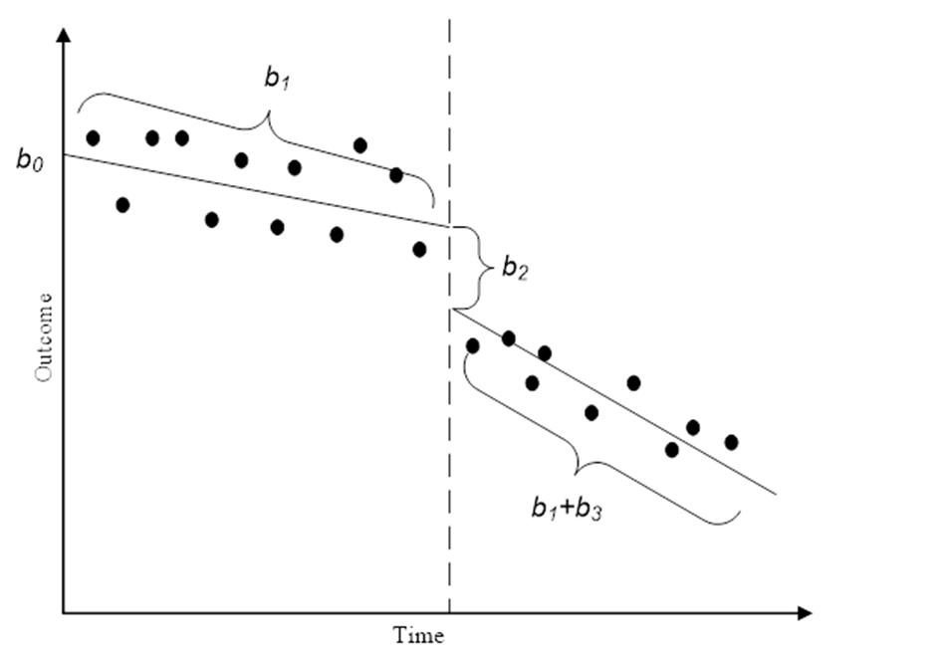

Figure 16. Representation of the Parameters of a Segmented Regression Model

This basic specification is used relating the outcome variables to the intervention variables described above. This model, however, still does not correct for temporal autocorrelation – where the observations of the outcome remain correlated even after adjusting for relevant covariates. Temporal autocorrelation is so named because observations nearer in time are likely more similar than observations that are more temporally distant. In this application, temporal dependence is a nuisance and the focus of correcting for temporal dependence is on correcting standard errors rather than formally modeling temporal dependence with ARIMA and related models. For this reason, Newey-West adjusted standard errors are used to remove the impact of temporal dependence (see Linden, 2015). Due to the large number of models that are examined, the recommendation of Greene (2008: 643) to set the Newey-West lag at approximately *T0.25* (or here 3) is followed. The computed standard errors from these models are also robust to heteroscedasticity.

Newey West Ordinary Least Squares (OLS) models provide important preliminary models for diagnostic purposes. The final OLS Newey West models for the area Outside the Buffer Zones are presented in Table 16 below. The first panel presents the model for violent crime with a firearm, the second panel presents the model for robbery with a firearm, and the final panel presents the model for aggravated assault with a firearm. In this model, the constant provides the level of crime at the beginning of the series, and the coefficient for time provides the trend in crime prior to any intervention. Only the constant was statistically significant in all models, suggesting that the initial level of crime was not zero. The four intervention variables test whether there is a significant decrease in crime associated with the timing of the other ShotSpotter interventions. Since these models are for the area outside of the buffer zones, none of the interventions should have a significant coefficient. These results are consistent as none of the intervention effects are statistically significant in any of the models.



Table 17 presents the Newey West OLS Models for the North Area. Following the segmented regression parameterization, the coefficient for the start time of the intervention (labelled Intervention – North) and the time × intervention interaction (Time x Interv. – North) captures the change in the level and trend of crime respectively after the ShotSpotter program began. In the model for violent crime with a firearm, the coefficient for the interaction is statistically significant; suggesting a decrease of 1.536 violent crimes per month after ShotSpotter began. This counteracts the pre-existing upwards trend of 1.105 crimes per month due to the coefficient for time. The net impact is that the trend changed from an increase of 1.105 violent crimes per month to a decrease of -0.431 crimes per month. The coefficient for the interaction effect is also statistically significant in the model for aggravated assault with a firearm. Because there is no pre-existing trend in this model, aggravated assaults with a firearm start decreasing by 1.490 per month after the intervention began. Importantly, none of the coefficients for the other interventions are statistically significant, indicating that crime did not change when ShotSpotter was activated in the other areas.



The results for the Newey West OLS regression models for the West Area are presented in Table 18. The coefficient for the intervention for the West Area was statistically significant in the model for violent crime with a firearm, suggesting that there were 9.282 fewer crimes the month that ShotSpotter came online. Similarly, this coefficient was significant in the model for robbery with a firearm, indicating that these crimes decreased by 5.300 when the ShotSpotter intervention began. Both the coefficients for the intervention and the time × intervention interaction are statistically significant in the model for aggravated assault with a firearm, which points to an immediate decrease of 4.688 crimes when the program began and a decrease of 0.430 crimes per month in the pre-existing trend, which considerably slows the increase. Unfortunately, the coefficients corresponding to the North Area intervention are statistically significant in the models for violent crime with a firearm and aggravated assault with a firearm. This weakens the conclusions from the North Area models as both the North Area and the West Area experienced decreases in these crimes at the same time.



Table 19 highlights the results of the Newey West OLS models for the Montbello Area. In these models, the only statistically significant variable is the constant. There is no evidence that the ShotSpotter intervention in Montbello led to a decrease in any of the three outcomes. Further, there is no evidence that there were changes in crime corresponding to timing of interventions in any of the other areas.



The final Newey West OLS regression models for the East Colfax area are presented in Table 20. The coefficients for the intervention time for Montbello are all statistically significant in each model, but the coefficients for the time for East Colfax are not. The only intervention effect that is statistically significant is the time × intervention interaction for robbery with a firearm. These results suggest that robbery with a firearm began decreasing by 0.129 robberies per month after ShotSpotter came online.



Although the OLS models are very useful, they do not correct for the measurement of the outcomes in question. All of the outcome variables are counts of crime, and using OLS regression for count data can result in biased coefficients and inappropriate standard errors. Because the dependent variables under investigation represent counts of events, a negative binomial Newey-West model is needed. The negative binomial model is one of a number of distributions related to the Poisson distribution that is specifically designed for count variables. The main difference between the standard Poisson and the negative binomial distribution is that the negative binomial distribution introduces an additional term to control for overdispersion – when the mean of the Poisson distribution is not equal to its variance (see Cameron & Trivedi, 1998). Following the recommendation of Long & Freese (2014), (*exp*(*b*) – 1) can be interpreted as the percentage change in the count of events for a one unit increment in the independent variable.

The first Newey West negative binomial regression model for the area Outside the Buffer Zones are shown in Table 21. Again, the model for violent crimes with firearms is presented in the first panel, the model for robberies with firearms is presented in the second panel, and the model for aggravated assaults with firearms is presented in the final panel. In the model for violent crime with a firearm, only the constant is statistically significant. However, the joint test reported here tests the null hypothesis that all unrelated intervention coefficients are equal to zero – that crime did not change due to an intervention outside of the area. This test is statistically significant, which suggests that some outside intervention did result in a change in crime. In the model for robbery with a firearm, the only significant coefficient is the constant, and the joint test is not statistically significant. For aggravated assault with a firearm, the constant was statistically significant as was the coefficient for the intervention in the North Area. The joint test is also statistically significant suggesting that the outside interventions had an impact on crime.



The negative binomial Newey West models for the North Area are provided in Table 22. In the model for violent crime with a firearm, the coefficients for time and the time × intervention interaction are statistically significant. Taken together they suggest that violent crime with a firearm was increasing by 6.18 percent per month prior to ShotSpotter coming online, but then began decreasing by 1.59 percent per month after ShotSpotter began. The joint test is not significant, indicating that the timing of other interventions had no impact on gun-related violent crime in the North Area. In the model for robbery, only the constant is statistically significant, and the joint test was not significant. For aggravated assault with a firearm, the coefficient for time and the time × intervention variables are significant; suggesting that gun-related aggravated assaults were increasing by 10.52 percent per month but then began decreasing by 1.49 percent per month after ShotSpotter came online. The joint test for the coefficients of the West, Montbello, and East Colfax interventions is not significant and therefore these interventions did not affect crime in the North Area.



Table 23 presents the results of the negative binomial Newey West models for the West Area. In the model for violent crime with a firearm, the coefficients for time, the intervention for the West Area, and the time × intervention interaction are statistically significant. These effects indicate that violent crime increased by 7.04 percent prior to ShotSpotter coming online. After ShotSpotter began, violent crime dropped by 54.61 percent and only increased by 1.11 percent per month thereafter. The coefficient for the intervention in the North area was statistically significant, but the joint test was not significant, providing mixed evidence on whether outside interventions had an impact on gun-related violent crime in the West Area. The coefficient for the intervention is statistically significant in the model for robbery with a firearm, indicating that robbery with a firearm dropped by 75.5 percent the month that ShotSpotter came online. Finally, the coefficients for time, the intervention, and the time × intervention interaction were significant in the model of aggravated assaults with a firearm. Aggravated assaults with a firearm were increasing by 8.65 percent per month prior to ShotSpotter coming online, and then decreased by 48.83 percent the month ShotSpotter started and then only increased by 0.70 percent per month thereafter. Also, in this model, the coefficient for the intervention in the North Area was statistically significant, but the joint test was not significant.



The negative binomial Newey West models for the Montbello Area are provided in Table 24. Besides the constants, there was only a single significant coefficient across the three models. In the model for violent crimes with a firearm, the coefficient for the intervention was statistically significant, indicating a drop of 47.43 percent in violent crimes with a firearm the month that ShotSpotter began. The joint tests for all models are not statistically significant, which suggests that none of the interventions from the other areas were associated with a crime drop in the Montbello Area.



The final negative binomial Newey West models for the East Colfax Area is presented in Table 25. Neither the coefficient for the intervention nor the coefficient for the time × intervention interaction are statistically significant, indicating that ShotSpotter did not have an impact on gun-related crime in the East Colfax area. In the model for violent crime with a firearm, the coefficient for the West Area and Montbello Areas are statistically significant. Based on these coefficients, it appears that violent crime with a firearm significantly increased when the West Area came online and then significantly decreased when the Montbello Area came online. The model for aggravated assault with a firearm shows the same pattern with these coefficients. The joint test is statistically significant in all three models.



Table 26 provides a summary of the results for the final GLM negative binomial Newey West models for each of the outcome variables. Asterisks are used to indicate the significance level of the coefficient for the intervention, the coefficient for the time x intervention interaction, and the joint test. The final column notes the outside interventions that have statistically significant coefficients. From this table, it is clear that the strongest evidence for the impact of ShotSpotter was seen in violent crime with a firearm and aggravated assault with a firearm in the North Area and all three gun-related crimes in the West Area. There is also some support for a reduction in violent crime with a firearm in the Montbello Area. These positive results are tempered, however, based on the results from the joint test and coefficients from the outside interventions. While the North Area experienced a decrease in violent crimes with firearms and aggravated assaults with firearms after the intervention, the West Area and the area outside the buffer zones experienced a similar decrease in these crimes near the same time. This finding implies that outside events cannot be ruled out as the source of the crime decrease. Crime decreases were also observed in the West Area after ShotSpotter came online; however, increases in these crimes were observed in the East Colfax area at the same time. This implies that the effects observed in the West Area might in part reflect crime displacement rather than true crime reductions. Finally, the reduction in violent crime with a firearm observed in the Montbello Area was also observed in the East Colfax area at the same time. In short, while these models suggest that there are some promising effects of ShotSpotter on crime, these findings are ambiguous to some extent and the true impact of ShotSpotter remains inconclusive.

